Parameter estimation
Business statistics are a set of tools to convert data into information to aid decision making
- Population: the set of all possible values of a parameter
- Parameter: a summary measure of population values
  - Mean: μ
  - Variance: σ²
  - Standard deviation: σ
  - Population size: N
- Sample: a subset of the population
- Statistic: a summary measure of sample values
  - Mean: m
  - Variance: s²
  - Standard deviation: s
  - Sample size: n
- Inference: drawing conclusions for the population from the sample

Measures of central tendency
- Mean
- Median
- Mode

Measures of variation
- Variance: measures the spread of outcomes from the mean. In business we seek to reduce variance of output
- Standard deviation: square root of variance
  - If X is normally distributed, 66% of outcomes are within 1 standard deviation from the mean, 95% within 2 and 99% within 3

Calculating probabilities with normal distributions
- Machine produces items whose weight follows N(510, 2.5²). Probability that an item weighs more than 515 grams?
- Convert to standard normal distribution where N(0,1).
  - Z = X – U / σ
- Look this value up in standard normal distribution table

Confidence intervals
- An interval estimate produces a range for the population mean, and is subject to less sampling error than a point estimate which produces a single value for m
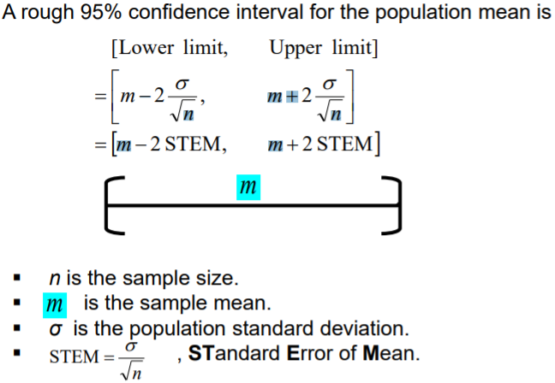

- To construct a confidence interval for a population mean, choose a sample size n, and sample n observations independently from the population.
  - Calculate the average m of n observations, which is a point estimate of the population mean (u).
  - Calculate population standard deviation, which can also be approximated by the sample standard deviation
  - Calculate STEM
  - Choose confidence level and find the corresponding critical value of z
  - Construct a confidence interval for the population mean
    - [m – z*STEM, m + z*STEM]
- To construct a confidence interval for a population proportion, choose a sample size n, and sample n observations independently from the population.
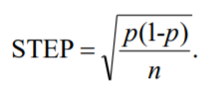
  - Calculate the proportion q of n observations, where q is an estimate of the population proportion (p)
  - Calculate STEP (standard error of proportion)
  - Choose a confidence level and find the corresponding z critical value
  - Construct a confidence interval for the population proportion
    - [q – z*STEP, q + z*STEP]

Evaluation of confidence intervals
- We need to understand how confidence intervals change with confidence levels and sample sizes. We also need to understand how to use and interpret confidence intervals
- We can conduct sensitivity analysis on confidence intervals. From the formula, we know we can decrease the confidence interval by either increasing the sample size n, or decreasing the confidence level.
  - Increasing n decreases STEM
    - Increasing a sample size from n to 4n shrinks the confidence interval by a half
  - Decreasing confidence level decreases critical z value

- Confidence intervals are often approximate, so can use this when evaluating answers
  - Use exact z values instead of estimates e.g. 1.96 instead of 2, 2.58 instead of 3
  - If the population standard deviation is not available, it is approximated using s
  - If population proportion is not available, it is approximated using q(1-q)
- Meaning of confidence intervals: 95% of all 95% confidence intervals will contain the population mean
  - Sample mean is an uncertain number distributed in a bell curve, whose mean is the population mean and whose standard deviation is STEM.
  - Z*STEM is the margin of error, which is the half length of the confidence interval

Hypothesis testing
- Confidence intervals are used to estimate population parameters such as population means and proportions, but managers often want to test if a target has been achieved or a hypothesis about a parameter is valid. Here, we use hypothesis testing to make inferences based on data
- When a statistical value changes, it could be just due to sample variation and not an underlying change in the population parameter

Make hypotheses
- Question is about a changing defect rate, so proportions are used
- NH or H₀: Adam’s current defect rate is the same as before: q = p
- AH or H₁: Adam’s current defect rate is different from before q $≠$p

Calculate test statistic
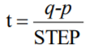
- We need to reject or not reject NH based on statistical evidence. T-statistic is calculated by:

Make a comparison
- At the 5% significance level (or 95% confidence level), we expect variations of up to 2 STEP. Here, the distance between p and q is much smaller, at 0.51 STEP

Make a conclusion
- At the 5% significance level we do not reject NH, that the sample proportion is the same as the population proportion, meaning the defect rate has not changed.

Framework for testing proportion hypotheses
- Assume q is the sample proportion and p is the population proportion.
- Make a NULL hypothesis: q = p, and an ALTERNATIVE hypothesis: q ≠ p.
- Select a significance level α and find out its critical value z
- Calculate test statistic: t = (q - p)/STEP.
- Compare t with the critical value z.
- Reject NH if the absolute value of t is larger than z. Otherwise, do not reject NH.

Framework for testing mean hypotheses
- Assume m is the sample mean and μ is the population mean.
- Make a NULL hypothesis: m = μ, and an ALTERNATIVE hypothesis: m ≠ μ.
- Select a significance level α and find out its critical value z.
- Calculate test statistic: t = (m - μ)/STEM.
- Compare t with the z-value.
- Reject NH if the absolute value of t is larger than the z value. Otherwise, do not reject NH.

Sensitivity analysis of conclusions
- The larger significance level is, the more likely it is that the NH will be rejected, as the z value will be smaller.
- How does sample size affect conclusions?

Alternative to hypothesis testing
- Construct a confidence interval at a confidence level corresponding to the significance level needed
- Compare the confidence interval to the statistic in question

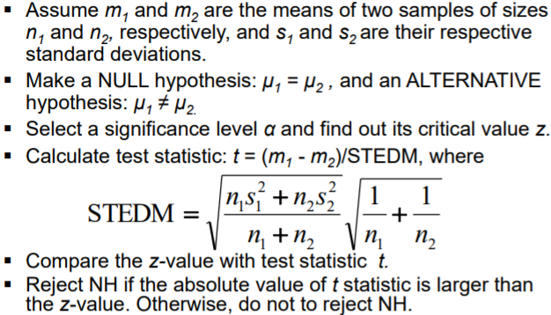
Difference of two means hypothesis testing

